COVID-19 Update: Epi week 14-20 June 2020

Over 8.7 million cases confirmed and reported, with over 461,000 deaths reported to date (unofficially over 8.9 million cases and over 468,000 deaths, over 3.7 million active cases and over 4.7 million recovered). Brazil, the US, Mexico and India are reporting the highest daily increases in deaths, Brazil, US, India are reporting the highest daily increases in new cases. Highest daily increase thus far on Thursday, June 18th with 150,000 new reported cases.

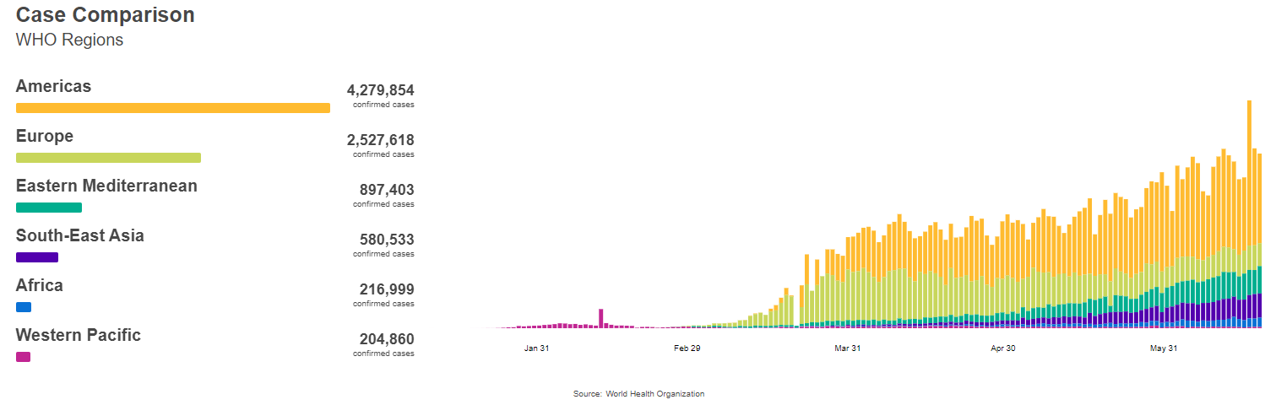
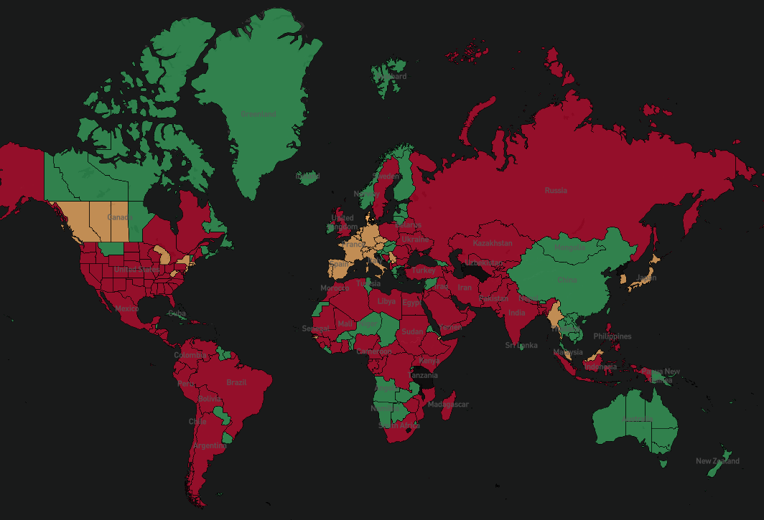
Classification of countries that have improved/ continue to improve action for COVID-19 (green), countries that are close (yellow), and countries that still need to take major action (red), based on reported case numbers and trends

Weekly update (official) based on locations with highest case increases – last updated: WHO SitRep #151

Americas Region  Country | Daily change in new reported cases (decreasing shown in blue, increasing in red)
 | Sunday  14-June | Monday  15-June | Tuesday  16-June | Wednesday  17-June | Thursday  18-June | Friday  19-June | Saturday  20-June
United States | 25 314 | 21 754 | 18 514 | 27 921 | 23 139 | 23 046 | 36 617
Brazil | 21 704 | 17 110 | 20 647 | 34 918 | 32 188 | 22 765 | 54 771
Peru | 4 383 | 4 604 | 3 256 | 4 164 | 3 752 | 3 480 | 3 537
Chile* | 6 938 | 5 143 | 5 013 | 36 179 | 4 475 | 6 290 | 5 355
Mexico | 3 494 | 4 147 | 3 427 | 4 599 | 4 930 | 5 662 | 5 030
High daily increases also reported in Colombia, Argentina
*31,422 of the newly reported cases in Chile (reported on the 18th) were from reconciling data activities
European Region  Country | Daily change in new reported cases (decreasing shown in blue, increasing in red)
 | Sunday  14-June | Monday  15-June | Tuesday  16-June | Wednesday  17-June | Thursday  18-June | Friday  19-June | Saturday  20-June
Russia | 8 246 | 8 248 | 7 843 | 7 790 | 7 972 | 7 889 | 7 728
UK | 1 514 | 968 | 1 279 | 1 115 | 1 218 | 1 346 | 1 295
Spain | 323 | 181 | 219 | 355 | 585 | 307 | 363
Italy | 338 | 301 | 210 | 328 | 331 | 0 | 264
Germany | 192 | 378 | 345 | 580 | 0 | 601 | 687
Turkey | 1 562 | 1 592 | 1 467 | 1 429 | 1 304 | 1214 | 1 248
Ukraine and Sweden, Belarus also seeing elevated daily case numbers
MENA Region  Country | Daily change in new reported cases (decreasing shown in blue, increasing in red)
 | Sunday  14-June | Monday  15-June | Tuesday  16-June | Wednesday  17-June | Thursday  18-June | Friday  19-June | Saturday  20-June
Iran | 2 472 | 2 449 | 2 563 | 2 612 | 2 596 | 2 615 | 2 322
Saudi Arabia | 4 233 | 4 507 | 4 267 | 4 919 | 4 757 | 4 301 | 3 941
Qatar | 1 186 | 1 274 | 1 201 | 1 097 | 1 267 | 1 021 | 1 026
Egypt | 1 618 | 1 691 | 1 567 | 1 363 | 1 218 | 1 774 | 1 547
UAE | 304 | 342 | 346 | 382 | 388 | 393 | 388
Significant increases also observed in Iraq and Oman
Asia Pacific Region Country | Daily change in new reported cases (decreasing shown in blue, increasing in red)
 | Sunday  14-June | Monday  15-June | Tuesday  16-June | Wednesday  17-June | Thursday  18-June | Friday  19-June | Saturday  20-June
India | 11 502 | 10 667 | 10 974 | 12 881 | 13 586 | 14 516 | 15 413
Pakistan | 5 248 | 4 443 | 5 839 | 5 358 | 4 944 | 6 604 | 4 951
Bangladesh | 3 141 | 3 099 | 3 862 | 4 008 | 3 803 | 3 243 | 3 240
Singapore | 407 | 214 | 151 | 247 | 257 | 142 | 218
Indonesia | 857 | 1 017 | 1 106 | 1 031 | 1 331 | 1 041 | 1 226
Philippines | 538 | 490 | 361 | 457 | 561 | 660 | 941
Afghanistan | 761 | 106 | 1 241 | 463 | 541 | 419 | 536

Africa Region  Country | Daily change in new reported cases (decreasing shown in blue, increasing in red)
 | Sunday  14-June | Monday  15-June | Tuesday  16-June | Wednesday  17-June | Thursday  18-June | Friday  19-June | Saturday  20-June
South Africa | 4 302 | 3 495 | 2 801 | 4 078 | 3 478 | 3 825 | 4 966
Nigeria | 904 | 573 | 490 | 587 | 745 | 667 | 661
Ghana | 304 | 542 | 229 | 397 | 339 | 274 | 514
Cameroon | 829 | 292 | 0 | 0 | 0 | 774 | 0
Senegal | 94 | 0 | 157 | 122 | 106 | 164 | 144
High daily increases also reported in Ethiopia, Gabon, Kenya and Congo, Côte d’Ivoire, Mauritania, CAR
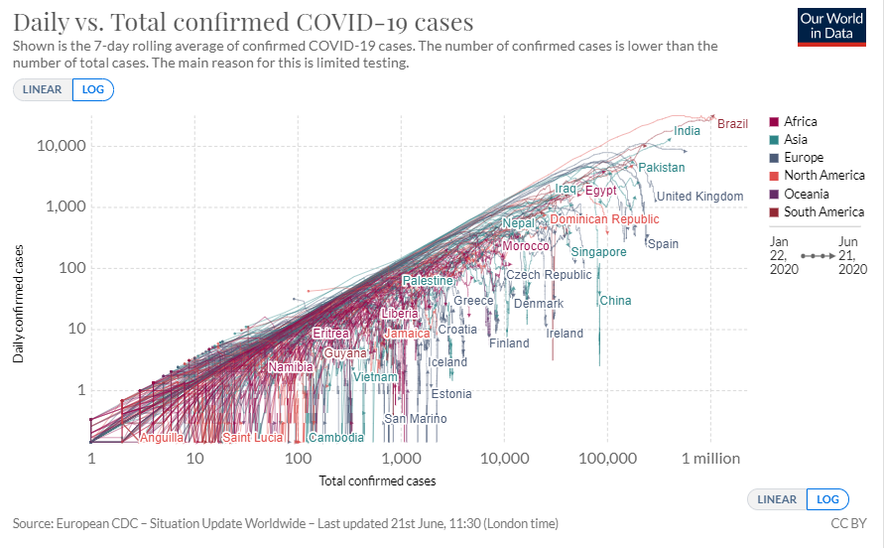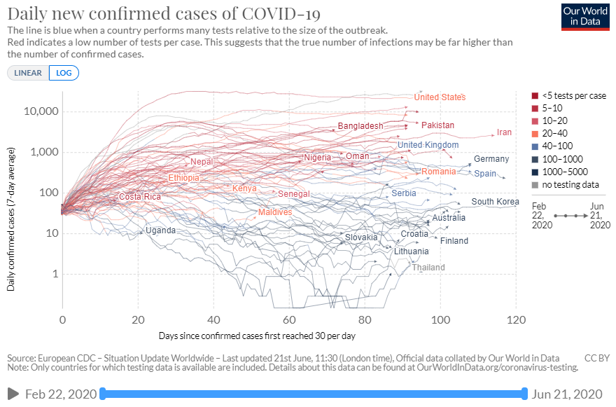

News/ Political Context
- Daily confirmed deaths increasing most rapidly in Equatorial Guinea, Comoros, CAR, Suriname, Benin, Iraq, Malawi, Libya, Ethiopia, Angola.
- Cases doubling rapidly in Eritrea (7 days), Mauritania (9 days), Benin (9 days), Surinam (10 days), Botswana (11 days), Nepal (11 days), Iraq (11 days).
- Antibody testing in Geneva suggests 10.8% of Geneva residents have been infected by COVID-19. Among participants 65 and over an estimated 96% avoided infection meaning an estimated CFR for those over 65 is around 8% while the entire population is around 0.5%. Antibody testing should be interpreted with some caution.
- PAHO urging increased cooperation among country border areas along migration routes where health infrastructure is often low and there are reports of increased transmission rates. Specific concern was raise for the border of Dominican Republic and Haiti and along the northern borders of Brazil.
- Africa region seeing an increase in cases, taking 98 days to reach 100,000 and 19 days to reach 200,000 confirmed cases. To date 227,752 PCR kits and 104,000 sample selection kits have been sent and distributed throughout the region
  - COVID-19 treatment centers have been established in Senegal, Tanzania, Burkina Faso, Sao Tome and Principe, Nigeria, Republic of Congo, Ivory Coast, Tanzania, Mauritius and Ghana
  - WHO has procured 2,522 oxygen concentrators and 487 ventilators, for WFP to deliver across the region
- Update on renewed outbreak in China: a total of 172 new cases have been reported in the country since June 11th (158 in Beijing, 10 Hubei province, 2 Liaoning Province, 1 in Sichuan Province and 1 in Zhejiang Province)
- Increased reports of home violence in many countries during COVID-19. Updated guidance shared below.
- European Region accounts for 31% of COVID-19 cases and 43% of COVID-19 deaths globally
- Resurgent daily increase in cases in Iran likely due to both re-opening following confinement measures as well as a significant increase in testing capacity – highlighting many confirmed COVID-19 cases are community-based rather than always in the health facility.
- Increased outbreaks in prisons in multiple countries

Recent Research/ Evidence
- Research has shown the benefits of breastfeeding outweigh the potential risks of transmitting COVID-19
  - Unless severely ill and unable to care for their baby, mothers and infants should not be separated and skin-to-skin contact and early initiation of breastfeeding is encouraged to mothers even if COVID-19 positive.
- Updated guidance on releasing COVID-19 patients from isolation given recent findings. While patients whose symptoms have resolved may test positive for COVID-19 for several weeks, these patients are likely no longer to be infectious
- Symptom screening in long-term care facilities showed low sensitivity and specificity in detecting COVID-19 among residents. Authors suggest the need to incorporate wide-scale testing in communal living scenarios to better detect for COVID-19.

Clinical Trails
- More than 120 different candidate vaccines are under development and could be available or suitable to enter the trial at different times
- Promising results of clinical trial of Dexamethasone, reduces risk of dying by 20% for those in critical condition receiving oxygen, and by one third by those on ventilators. The findings have major implications as the steroid is generally widely available and low cost.
- The hydroxychloroquine arm of the Solidarity Trial, which seeks to find an effective COVID19 treatment, is being stopped. Decision made following evidence that hydroxychloroquine does not result in the reduction of mortality when compared to standard care.

Modeling
- ICL examination of NHS decisions to reduce non-essential procedures, and evidence suggests elective interventions should not be scaled-back up until COVID-19 patients drop below 7,500.
- Projections for the reproductive number and deaths (ICL weekly projections) Assuming the underlying CFR 1.38% forecasting for the upcoming weeks are below:
  - Europe: Continuing to increase in Armenia, Azerbijan, Moldova, Russia, Ukraine and North Macedonia. Projected reproduction numbers expected to remain the same or decrease in Portugal, Netherlands, Italy, Germany, France and the UK
  - MENA: Effective reproductive rate expected to increase in Iraq, Saudi Arabia, Egypt, and Yemen, with continued decreases continuing in UAE and Kuwait.
  - Asia Pacific: Effective reproductive rate expected to increase in Pakistan, the Philippines, Bangladesh, Indonesia and India, with Afghanistan rates remaining constant.
  - Africa: Nigeria and South Africa expected to continue to see large increases while DRC and Kenya expected to see continued rise.
  - Americas: Effective reproductive predicted to increase in Dominican Republic, Peru, Argentina, and Bolivia.
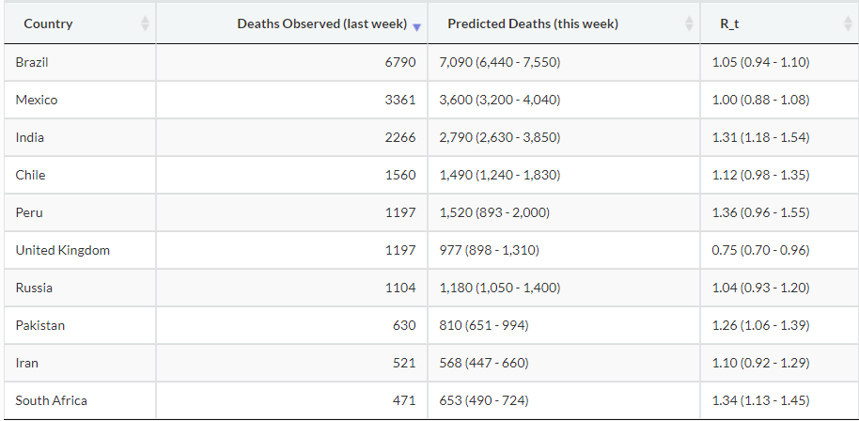

Humanitarian Impacts
- Yemen facing major health crisis with only 50% of Health system functioning and many HCWs not receiving payment. Current CFR estimates in Yemen for COVID-19 is 25% and is 4 times higher than global average
- Evidence showing the need to engage communities better in the response to coronavirus rather than a top-down approach, and the importance of addressing underlying causes of inequality which lead to increased risk of COVID-19 to make progress on ending high transmission.
- Updated modeling estimates of COVID-19 on refugee camps suggests that due to low capacity to maintain non-medical strategies to reduce transmission such as social distancing and adequate water and sanitation, following initial introduction of the virus 70-98% of the camp population would be expected to be infected within the first year assuming no effective interventions are taken.
  - Hospitalization needs were are expected to be exceeded as soon as 55 days following the introduction of COVID-19 into the community.
  - Using the Kutupalong-Balukhali Expansion Site for the modeling scenarios, deaths are estimated to be between 2,040 – 2,880 from low to high transmission scenarios.
- To-date over 1,600 cases have been identified in Cox’s Bazar district, with 38 cases and 2 deaths reported among Rohingya refugees
- Mapping of COVID in Humanitarian settings available here

Guidance Launched or Highlighted This week
- Guidance on maintaining essential services
- WHO R&D Blueprint
- Addressing violence against children, women and older people during the covid-19 pandemic: Key actions
- Update: Criteria for releasing COVID-19 patients from isolation
- Release of new tool: Emergency Global Supply Chain System (COVID-19) catalogue
  - The following catalogue lists all medical devices, including personal protective equipment, medical equipment, medical consumables, single use devices, laboratory and test-related devices that may be requested through the COVID-19 Supply Portal.
Useful Sources
Some additional sources – such as specific journal articles are shared as a foot note and saved to the “Evidence” folder in Teams.
ALNAP launched COVID-19 response portal
BMJ COVID-19 resources
European Centre for Disease Prevention and Control
End Coronavirus Visualizations
Global Health 5050 Sex desegregated data
Health Map
Imperial College of London
ISARIC COVID-19 resources
Johns Hopkins Center for Health Security and CSSE
Humanitarian platform for COVID-19
The Lancet
LSHTM COVID-19 mapping tool
New England Journal of Medicine
Next Strain (Phylogeny of SARS-CoV-2)
Our world in Data
PLOS COVID-19
ProMed
WHO
MobLabs
MobLabs Domestic and international risk of importing a case
World Meters

Official numbers and WHO visualizations available here
https://www.endcoronavirus.org/countries
https://ourworldindata.org/coronavirus
Reference to ECDC data using https://ourworldindata.org/coronavirus
Le News 16 June 2020
PAHO – containing the spread of COVID-19 in vulnerable populations in border regions
WHO Sit Rep #149
WHO Sit Rep #150
Lancet 20 June 2020
WHO benefits of breastfeeding
https://www.who.int/publications/i/item/criteria-for-releasing-covid-19-patients-from-isolation
NEJM 21 May 2020
Nature 16 June 2020, WHO 16 June 2020
WHO Update 17 June 2020
ICL Report #27
Lancet 15 June 2020
PLOS Medicine 16 June 2020

