**This document forms the template that other countries can adapt for their own.**

**Where you see XXX please enter your country specific information.**

**Please amend annex’s if your country has specific examples.**

**Your governments guidelines should always be adhered to.**

**Once you have adapted please delete this comment.**

**Staff Health Guidelines – COVID-19**

Contents

**What is COVID-19?** 2

**What are the symptoms of COVID-19?** 2

**Vaccination, Testing, and Isolation Centers** 2

**How does COVID-19 spread?** 3

**Terminology – what do all these terms mean to me** 3

**Self-isolation if you are feeling unwell** 4

**At Work** 5

**What do I need to stay protected?** 6

**Visitors and Staff** 6

**Equipment** 7

**Thermometer** 7

**Soap** 8

**Water** 8

**Hand sanitizer** 8

**Bleach** 8

**What to do if you or a family member or yourself have symptoms?** 9

**What equipment do I need if I have to care for a family member at home?** 9

**How do I care for a family member at home?** 9

**Annex 1 Self-Monitoring** 10

**Annex 2 – Handwashing with Soap and Water** 11

**Annex 3 – Handwashing with hand sanitizer** 12

**Annex 4 – Making Up Chlorine for Cleaning and Handwashing** 13

**Annex 5 – How to Remove Gloves** 15

**Annex 6 Caring for Someone at Home** 16

## **What is COVID-19?**

On December 31, 2019, the World Health Organization (WHO) was informed of collective cases of pneumonia of unknown origin detected in Wuhan, in the province of Hubei in China. Since December 8, 2019, the first cases presented symptoms related to the SARS coronavirus, which belongs to the subgenus Sarbecovirus. The coronavirus that caused the pneumonia epidemic was declared as public health emergency of international concern by WHO on January 30, 2020.

## **What are the symptoms of COVID-19?**

The most common symptoms of COVID-19 are **fever, tiredness, and dry cough**. Some patients may have aches and pains, nasal congestion, runny nose, sore throat or diarrhea. These symptoms are usually mild and begin gradually. Some people become infected but don’t develop any symptoms and don't feel unwell.

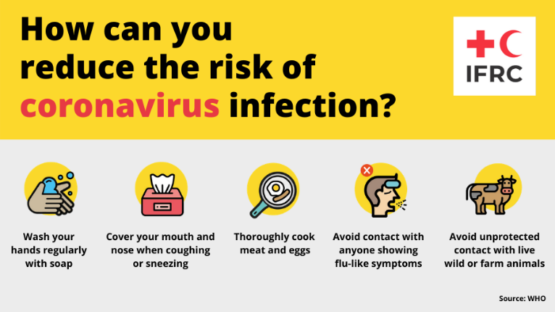If you develop **emergency warning signs** for COVID-19 get medical attention immediately. Emergency warning signs include*:

* Fever/Temperature
* Difficulty breathing or shortness of breath
* Persistent pain or pressure in the chest
* Dry cough
* Flu like symptoms – body aches, tiredness

*This list is not all inclusive. Please consult your medical provider for any other symptoms that are severe or concerning.

**Most people (about 80%) recover** from the disease without needing special treatment. Around 1 out of every 6 people who gets COVID-19 becomes seriously ill and develops difficulty breathing. Older people, and those with underlying medical problems like high blood pressure, heart problems or diabetes, are more likely to develop serious illness. People with fever, cough and difficulty breathing should seek medical attention.

## **Vaccination**

There is **no vaccine** currently available for COVID-19.

Your advice line in country can advise you on medications to reduce symptoms.

It is important we all take responsibility for stopping the spread of the disease.

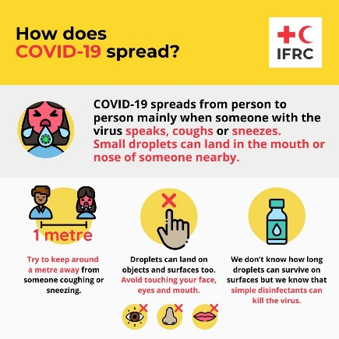

## **How does COVID-19 spread?**

When someone who has COVID-19 coughs or exhales they release droplets of infected fluid. Most of these droplets fall on nearby surfaces and objects – such as tables.

People could catch COVID-19 by touching contaminated surfaces or objects – and then touching their eyes, nose or mouth. If they are standing within one meter of a person with COVID-19 they can catch it by breathing in droplets coughed out or exhaled by them. In other words, COVID-19 spreads in a similar way to flu.

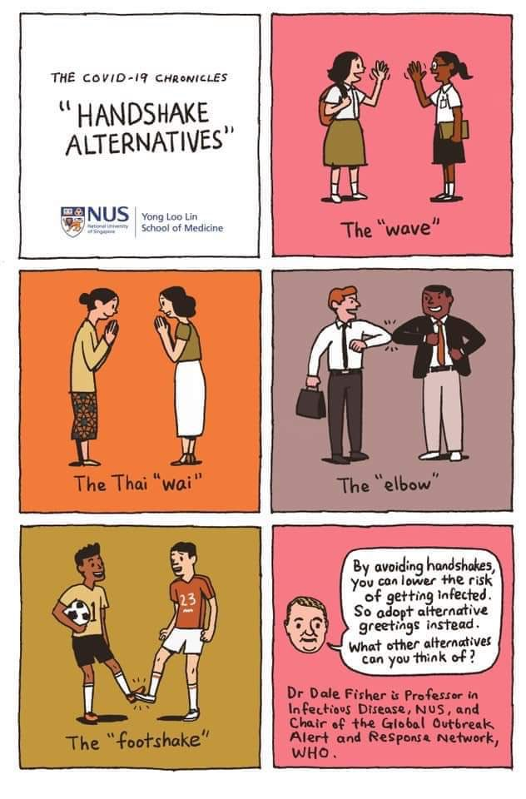Most persons infected with COVID-19 experience mild symptoms and recover. However, some go on to experience more serious illness and may require hospital care. Risk of serious illness rises with age: people over 40 seem to be more vulnerable than those under 40. People with weakened immune systems and people with conditions such as diabetes, heart and lung disease are also more vulnerable to serious illness.

The main way to stay safe is no touching. Greet people by touching each other heels, or elbows, bow in respect, put your hand on your own heart. All show respect without touching.

Talk in your family about how you will great people without touching.

## **Terminology – what do all these terms mean to me**

There is a lot of terminology about isolation, quarantine, social distancing. In most countries isolation and quarantine are the same thing.

If the government in your country has stricter rules those must be adhered to

|  |  |  |
| --- | --- | --- |
| **Terminology** | **IFRC terminology** | **What do you need to do** |
| Self-monitoring | Checking yourself to make sure you don’t have any of the symptoms of COVID-19. | See Annex 1 for a tool that all staff can use every day to help with good practices |
| Isolation | **Isolation** is used to separate symptomatic people from asymptomatic people. You might have been told you definitely have COVID-19 or you fit the case definition/symptoms and your government isn’t testing everyone. You may be sent to hospital or isolated at home. | You must separate yourself from everyone, separate out where possible the people you live with who have symptoms and those that don’t. Make sure that you clean the bathroom and kitchen after you use them and that no one is around when you use them. You may not be able to isolate yourself from everyone, for example if you are breastfeeding your baby. If you are unable to, make sure that IFRC are aware of who is staying with you. Clean all your surfaces frequently to remove any virus spores. Wash your clothes and eating utensils daily and don’t share. |
| Quarantine | Quarantine is used to separate and restrict the movement of people with no symptoms. It is designed to limit the spread and stop people who may have it but show no symptoms, they can still spread COVID-19. |
| Self-isolation and Quarantine | You have decided to separate yourself from others for good practice, or because you are a high-risk person. The government or IFRC may have requested but not forced you. | You might be a high-risk person, for example over the age of 60, have poor health that have highlighted you as a high-risk person who might get sick if you contract it. You therefore decide to quarantine to reduce your risk of catching it.  You might also be someone who thinks you might have been in contact with someone and although the government puts you at low risk, you decide to self-quarantine to reduce the risk of passing it on to anyone should you have positive. |
| Social distancing | Where possible **stop touching** other humans, keep a 1-2 meters distance from people, limit your interaction with people and wash your hands frequently | Only go out of your home if you need to, for work, buy food and water, going out for exercise. Wash your hands immediately on returning to your house and when entering any building (e.g. the shop).  Limit personal contact only with members of your immediate family. Where possible reduce this to vulnerable groups. Think of ways you can greet people without contact but while being respectful in your culture. |
| Lockdown | All other activities in this table are public health activities to reduce the spread of COVID-19. Lockdown is where staying at home is done due to political enforcement. This might be due to civil unrest rather than COVID-19 itself. | The government may announce a lockdown because civil unrest has happened or because the numbers are increasing and people aren’t following social distancing practice. They may arrest people who are breaking the rules. |

## **Self-isolation if you are feeling unwell**

1. Please stay home if you have any of the symptoms:

* Fever/Temperature
* Difficulty breathing or shortness of breath
* Persistent pain or pressure in the chest
* Dry cough
* Flu like symptoms – body aches, tiredness

1. Please call the advice line XXX if you have any breathing problems and/or any urgent or underlying medical condition.
2. Please note that if you are well enough to work but are staying home as a precaution, this will NOT be classed as sick leave but as ‘precautionary working from home’.
3. To relieve pressure on medical services, you do not now (and until further notice) need to produce a medical certificate until you have been off work and unable to work for more than **FIVE** days.

## **At Work**

Your office may already be closed, or you are able to work from home. If your office is still open then it is important you are prepared.

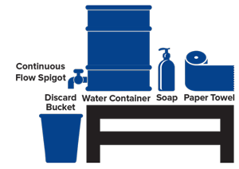Make sure that you have a handwash station at every entrance, gate, and building. This can be made or procured. Your WASH team will have expertise in this.

Everyone must wash their hands as they arrive in the building and follow the advice in the SOAP section on when to wash your hands.

Surfaces must be wiped down daily, and frequently used areas like door-handles and bathrooms must be cleaned every few hours. A cleaning **Rota** can be developed to assist cleaners to know how often certain areas should be cleaned.

Your desks must be paper free at the end of each day and as clean as possible throughout the day to make it easy for the cleaners to clean your area.

Make sure you have a plan of what happens if someone gets sick in the office, either during office hours or once they get home.

If someone in the office is confirmed as COVID-19 positive the office must be immediately closed, all staff are to self-isolate until further advice is given by the health authorities and staff health. The incident must be reported within 12 hours.

The plan should cover putting the ill person in a room or area where they are isolated from others in the workplace, limiting the number of people who have contact with the sick person.

The lead person should make a list of everyone who was in contact with that person. Consider

1. Who sits next to them or was in close contact with them during that day?
2. How did they get to work?
3. When did they start feeling sick?
4. Who do they live with?

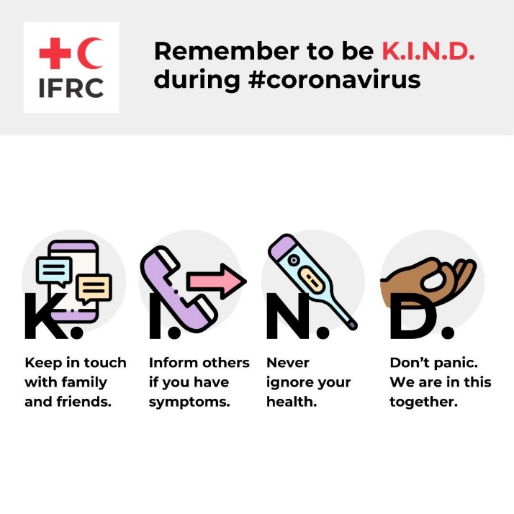Where possible get names, addresses and contact numbers. These can be passed onto health authorities and staff health.

All staff should wash their hands before leaving the office.

On arriving home, they must change their clothes immediately and wash with soap and hot water to reduce risk of transmission to other family members.

Remember the staff member who contracted COVID-19 needs support. Keep the member of staff name confidential to reduce any stigma. Only Staff Health need to know their name and contact details so they can follow up with any support. IFRC Hong Kong have developed some support documents which will be shared alongside this document that you might find useful or can be adapted to your country context.

## **What do I need to stay protected?**

Follow the IFRCs 3 actions

**Learn** all about COVID-19, get the facts not the myths. Stay updated

**Act** by following the best practice, for example handwashing, covering a cough or sneeze, stop handshaking and follow social distancing. Make sure you are following up to date actions by staying updated.

**Help** by thinking of others, can you safely help out family members who can’t look after themselves? Call your friends and check they are ok. Not physically being there for your friends and family doesn’t mean you can’t be there mentally.

## **Visitors and Staff**

The aim of social distancing and staying at home is to limit transmission. Therefore, it is important that you stop receiving visitors at home. If you employ people in your house you need to way up the risk. Answer these questions

1. Can you pay the person but ask them to stay at home? (remember they rely on the income for their family through this pandemic)

If NO

1. How does the person arrive at your home? Can you pay for a private personal taxi to reduce risk?
2. Do they live with a lot of people and therefore high risk themselves?
3. Do you know if they have any high-risk conditions that put them at high risk of getting very sick if they contract COVID-19?
4. Could you limit how often they come?
5. For security and other essential staff, make sure they have access to hand washing facilities and information so they can keep themselves safe
6. Do not put drivers at danger while keeping yourself safe. If they are assisting you in getting essentials to your home this must be done as infrequently as possible.

Finally

1. Make sure they have access to good knowledge themselves so they can make informed decisions for themselves and their families

Keep in mind that we can only overcome this pandemic if we all stay at home and when out we follow government guidelines and social distance. All need to make changes and potentially sacrifices to our lives but at the same time be kind, everyone needs their income to get through this and keep their families safe as well.

## **Equipment**

1. Thermometer
2. Soap
3. Water
4. Hand sanitizer
5. Bleach

### **Thermometer**

Each staff member must have access to a thermometer, this can be purchased locally. If it is being used by all the family and is placed in the mouth or under arm, clean the end with disinfectant or 0.5% chlorine and allow to dry, between each family member. If it is to be placed in your ear (tympanic) make sure you replace the plastic single use/person cap between each person. Follow the instructions on how to use your thermometer so you make sure the reading is correct.

There are two different measurements, Celsius and Fahrenheit. Celsius will have a C after the number and Fahrenheit will have an F. When reporting your temperature to a medical person, make sure you state which measurement you are using.

|  |  |  |  |  |  |  |
| --- | --- | --- | --- | --- | --- | --- |
| Temperature Celsius C | 35 or below | 35.1 - 36 | 36.1 - 37 | 37.1 - 38 | 38.1 – 39.4 | 39.4 or above |
| Temperature Fahrenheit F | 95 or below | 95.1-96.9 | 97 – 98.6 | 98.6 – 100.4 | 100.4 - 103 | 103 or above |
| Adults | Check*  Seek medical care | Low but possibly normal, recheck | Normal | Normal or low fever | Fever | High fever  Call for medical support |
| Children | Check*  Seek medical care | Low but possibly normal, recheck | Normal | Normal or low fever | Fever | High fever  Call for medical support |
| Babies (under 3 months old) | Check*  Seek medical care | Low  Call for medical support | Normal | Low fever, monitor | Fever  Call for medical support | High fever  Call for medical support |

Check* - make sure that the thermometer is being used correctly and in the right part of the human body

Never visit your medical provider. Always follow the guidance in your country and phone the advice line XXX

### **Soap**

Washing your hands with soap is the best way to protect you from contracting COVID-19. All type of soaps has the same disinfectant property against the corona virus. The chemicals in the soap will break the eternal protein cover of the virus and the virus will dry

You should wash your hands;

* **Before, during,** and **after** preparing food
* **Before** eating food
* **Before** and **after** caring for someone at home who is sick with vomiting or diarrhea
* **Before** and **after** treating a cut or wound
* **After** using the toilet
* **Afte**r [changing diapers or cleaning up a child who has used the toilet](https://www.cdc.gov/healthywater/hygiene/diapering/index.html)
* **After** blowing your nose, coughing, or sneezing
* **After** touching an animal, animal feed, or animal waste
* **After** touching garbage
* **Before** and **after** you are in building or taxi

See Annex 2 for how to wash your hands with soap

### **Water**

Being able to keep your home clean, washing hands and having good person hygiene is very important. Make sure that you can get enough water. If you don’t have running water in your home ensure you have some large buckets with lids to store water.

### **Hand sanitizer**

It is **not as goo**d as soap and water, but sometimes there is no running water available to wash your hands. Therefore, always carry hand sanitizer with you. Large shops will have hand sanitizer outside their buildings, smaller ones and taxi’s might not. Use your own when entering and exiting. See Annex 3 on how to use hand sanitizer correctly.

### **Bleach**

Bleach is chlorine, it comes in different strengths, the most common is 5% that you buy in supermarkets. The instructions in Annex 4 are following 5% bleach. If you don’t have 5% then you need to change the calculations to make sure it is safe to use. Please ask your WASH advisor for amendments.

You can use household detergents to clean surfaces, door handles etc. both at work and at home. However, you can also use bleach.

Follow the instructions on how to make them safely. The quantities are shown to make small volumes as you must throw it away and make up a new solution every 24 hours. The bleach stops being effective once it is made up after 24 hours.

**Bleach can kill, keep your mixed-up solutions away from children and animals and follow medical advice immediately if a child swallows it.**

## **What to do if you or a family member or yourself have symptoms?**

* If you have symptoms of high fever, cold, cough **stay at home**
* Separate the sick person from the rest of the house. Ideally in a separate room. Follow the guidance below
* Practice coughing/sneezing etiquettes (coughing/sneezing into your elbow and not on to your hands)
* Frequently wash your hands with soap. Alcohol-based hand rub is not a replacement for hand washing with soap
* Try to recall the persons with whom you had contract in the last 1 week, who had similar symptoms and, if possible, find out the health condition of those people (contacts)
* Call the advice line on XXX and follow their recommendations
* Check temperature regularly, monitoring for emergency warning signs that the advice line has told you
* Stay calm
* Hydrate, eat nutritious foods, and rest

**If staff members, or members of their household, exhibit any symptoms of COVID-19 they must inform their manager and work from home**.

## **What equipment do I need if I have to care for a family member at home?**

1. Thermometer
2. 1 x pack of paracetamol/ acetaminophen
3. 1 x pack of gloves
4. 1 x pack of masks

Paracetamol/ acetaminophen reduces someone’s fever. Always follow the instructions on the packet and make sure for an adult you never take more than 4grams in 24 hours.

Gloves and mask are needed if you need to provide care to the person who is COIVD-19 at home. These may be difficult to procure. Make sure you remove the gloves and mask correctly. If you remove them incorrectly you are putting yourself at high risk of contracting COVID-19. This is why they are recommended to only be worn when caring for a sick person. See Annex 5 for how to remove gloves.

## **How do I care for a family member at home?**

Annex 6 has a useful guide to caring for your family member at home.

If possible, only one person should provide the care, this is to limit the spread through a family. Isolate the person away from everyone else in the house and only provide care if it is necessary. If the person can do the task themselves then they must to limit the risk of the care giving contracting COVID-19.

Always follow the guidelines in your country. If the patient is getting worse tell the medical providers and follow the guidelines and support in your country.

## **Annex 1 Self-Monitoring**

This is good practice and should be done by all staff members to look for symptoms of COVID-19. Below is a useful tool to help you keep track. Start a new one each month. Place a N for No if you have no symptoms and a Y for Yes if you have. If you have any Y in any box then speak to your medical provider for support. If they suggest any actions then please update your staff health representative

|  |  |  |  |  |  |  |  |  |  |  |  |  |  |  |  |  |  |  |  |  |
| --- | --- | --- | --- | --- | --- | --- | --- | --- | --- | --- | --- | --- | --- | --- | --- | --- | --- | --- | --- | --- |
| **Symptoms** | **Day 1** | | **Day 2** | | **Day 3** | | **Day 4** | | **Day 5** | | **Day 6** | | **Day 7** | | **Day 8** | | **Day 9** | | **Day 10** | |
|  | **AM** | **PM** | **AM** | **PM** | **AM** | **PM** | **AM** | **PM** | **AM** | **PM** | **AM** | **PM** | **AM** | **PM** | **AM** | **PM** | **AM** | **PM** | **AM** | **PM** |
| Temperature/Fever |  |  |  |  |  |  |  |  |  |  |  |  |  |  |  |  |  |  |  |  |
| Dry cough |  |  |  |  |  |  |  |  |  |  |  |  |  |  |  |  |  |  |  |  |
| Shortness of breath |  |  |  |  |  |  |  |  |  |  |  |  |  |  |  |  |  |  |  |  |
| Difficulty in breathing |  |  |  |  |  |  |  |  |  |  |  |  |  |  |  |  |  |  |  |  |
| Flu symptoms |  |  |  |  |  |  |  |  |  |  |  |  |  |  |  |  |  |  |  |  |
| **Symptoms** | **Day 11** | | **Day 12** | | **Day 13** | | **Day 14** | | **Day 15** | | **Day 16** | | **Day 17** | | **Day 18** | | **Day 19** | | **Day 20** | |
|  | **AM** | **PM** | **AM** | **PM** | **AM** | **PM** | **AM** | **PM** | **AM** | **PM** | **AM** | **PM** | **AM** | **PM** | **AM** | **PM** | **AM** | **PM** | **AM** | **PM** |
| Temperature/Fever |  |  |  |  |  |  |  |  |  |  |  |  |  |  |  |  |  |  |  |  |
| Dry cough |  |  |  |  |  |  |  |  |  |  |  |  |  |  |  |  |  |  |  |  |
| Shortness of breath |  |  |  |  |  |  |  |  |  |  |  |  |  |  |  |  |  |  |  |  |
| Difficulty in breathing |  |  |  |  |  |  |  |  |  |  |  |  |  |  |  |  |  |  |  |  |
| Flu symptoms |  |  |  |  |  |  |  |  |  |  |  |  |  |  |  |  |  |  |  |  |
| **Symptoms** | **Day 21** | | **Day 22** | | **Day 23** | | **Day 24** | | **Day 25** | | **Day 26** | | **Day 27** | | **Day 28** | | **Day 29** | | **Day 30** | | **Day 31** | | |
|  | **AM** | **PM** | **AM** | **PM** | **AM** | **PM** | **AM** | **PM** | **AM** | **PM** | **AM** | **PM** | **AM** | **PM** | **AM** | **PM** | **AM** | **PM** | **AM** | **PM** | **AM** | | **PM** |
| Temperature/Fever |  |  |  |  |  |  |  |  |  |  |  |  |  |  |  |  |  |  |  |  |  | |  |
| Dry cough |  |  |  |  |  |  |  |  |  |  |  |  |  |  |  |  |  |  |  |  |  | |  |
| Shortness of breath |  |  |  |  |  |  |  |  |  |  |  |  |  |  |  |  |  |  |  |  |  |  | |
| Difficulty in breathing |  |  |  |  |  |  |  |  |  |  |  |  |  |  |  |  |  |  |  |  |  |  | |
| Flu symptoms |  |  |  |  |  |  |  |  |  |  |  |  |  |  |  |  |  |  |  |  |  |  | |

Fever = Temperature above 37.5c or 99.5f

Flu Symptoms = body aches and pains, runny nose, very tired

## **Annex 2 – Handwashing with Soap and Water**

<https://www.youtube.com/watch?v=3PmVJQUCm4E>

https://www.who.int/gpsc/clean_hands_protection/en/

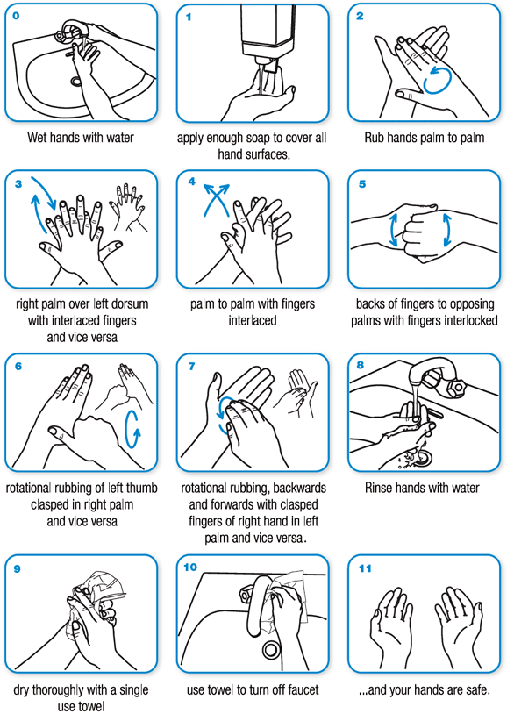

## **Annex 3 – Handwashing with hand sanitizer**

<https://www.who.int/gpsc/5may/How_To_HandRub_Poster.pdf?ua=1>

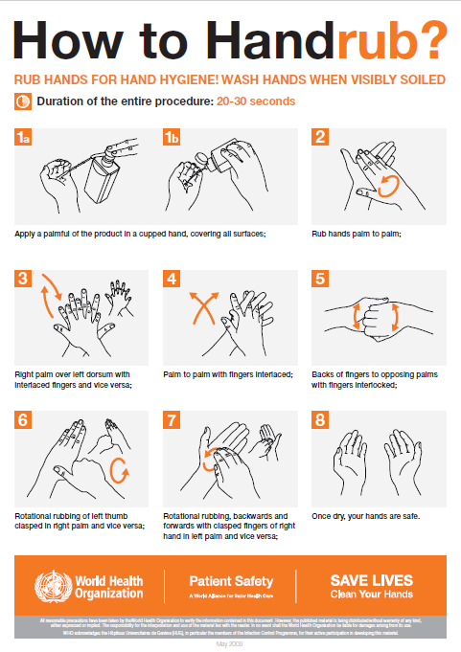

## **Annex 4 – Making Up Chlorine for Cleaning and Handwashing**

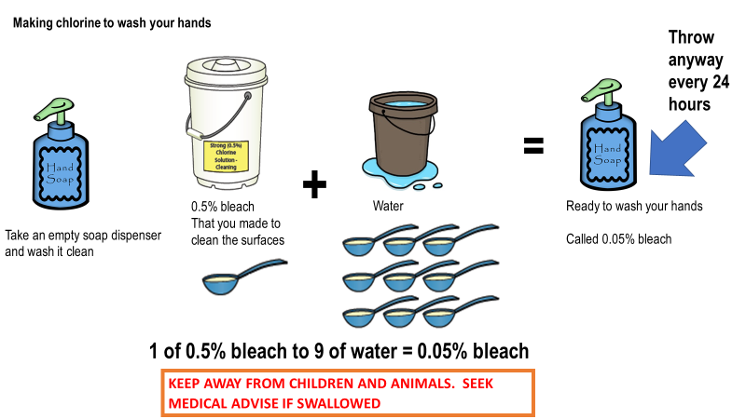

## **Annex 5 – How to Remove Gloves**

<https://www.globus.co.uk/assets/files/How-To-Safely-Remove-Your-Disposable-Gloves-A4-0615.pdf>

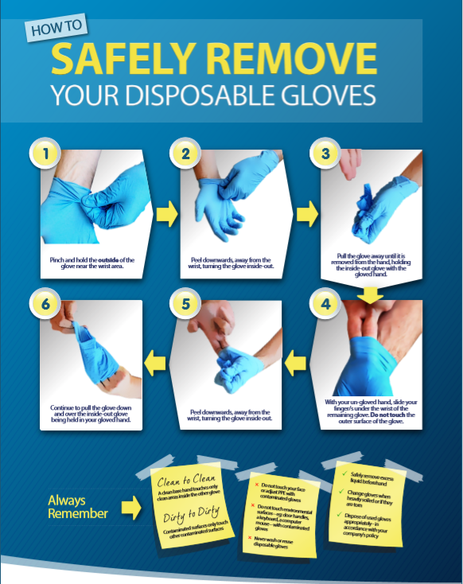

## **Annex 6 Caring for Someone at Home**

The home isolated person should:

Stay in a well-ventilated single-room preferably with an attached/separate toilet. If another family member needs to stay in the same room, it’s advisable to maintain a distance of at least 1-2 meter between the two.

• Needs to stay away from elderly people, pregnant women, children and persons with co-morbidities within the household.

• Restrict his/her movement within the room. • Under no circumstances attend any social/religious gathering e.g. wedding, condolences, etc.

He/She should at all times:

• Wash hand as often thoroughly with soap and water or with alcohol-based hand sanitizer • Avoid sharing household items e.g. dishes, drinking glasses, cups, eating utensils, towels, bedding, or other items with other people at home. • Wear a surgical mask at all the time. The mask should be changed every 6-8 hours and disposed of. Disposable masks are never to be reused. • Masks used by patients / care givers/ close contacts during home care should be disinfected using ordinary bleach solution (5%) and then disposed of either by burning or deep burial. • Used mask should be considered as potentially infected.

Instructions for the family members of persons being home isolated

• Only an assigned family member should be tasked with taking care of the such person • Avoid shaking the soiled linen or direct contact with skin • Use disposable gloves when cleaning the surfaces or handling soiled linen • Wash hands after removing gloves • Visitors should not be allowed • In case the person being isolated becomes symptomatic, all his close contacts will be home quarantined (for 14 days) and followed up for an additional 14days or till the report of such case turns out negative on lab testing

Environmental sanitation

a) Clean and disinfect frequently touched surfaces in the quarantined person’s room (e.g. bed frames, tables etc.) daily with 0.5% bleach

b) Clean and disinfect toilet surfaces daily with regular household bleach solution/phenolic disinfectants

c) Clean the clothes and other linen used by the person separately using common household detergent and dry.